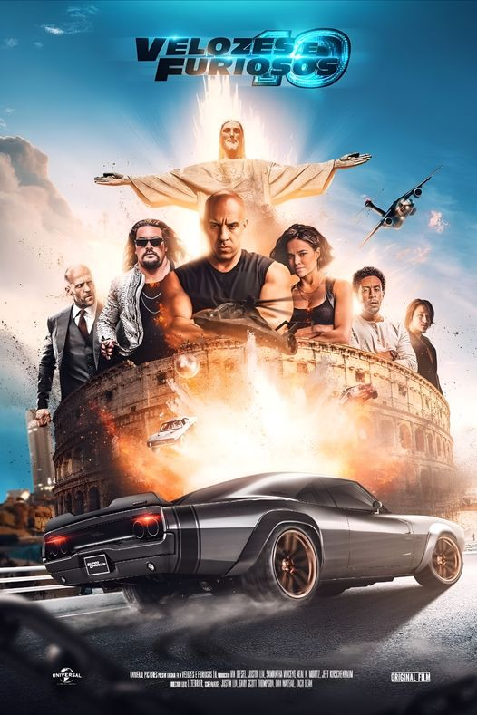


[JC City]
Jimbo crime city is a Kenyan streets- based action game. It is centered around three Characters Vin, Mych and Jawsay

[ZenodCompanies]
[Naivasha,Nakuru]
[0100424560]
[gilgadzenod47@gmail.com]

imbo
rime
J
C

Table of contents
JC Crime City Storyline 4
1.0 Introduction 4
2.0 Main Characters in Jimbo crime city 4
1. Vin 4
2. Mych 4
3. Jawsay 4
3.0 Other characters 5
4. Don 5
5. Gripper 5
6. Vert OG 5
7. Mulla Sub 5
8. Mchinks Sub G 5
9. Maker Sub G 5
10. Rio 5
11. Kuntah 5
Characters background 6
1) Vin 6

JC Crime City Storyline

Introduction
Jimbo crime city is a Jimbo streets- based action game. It is centered around three Characters Vin, Mych and Jawsay. The characters in the game joined the gangs for different reasons_revenge,undercover mission and hustle. As the game continues the three meet each other in a hostage and share out their cause of interest in joining the thuggery life. The three decide to merge up and try to run away out of the hostage. But will they succeed?And even after they succeed will they still find Vert? All this depends of you. Have fun out there.

Main Characters in Jimbo crime city

Vin
Vin is a University student in Kenyatta University.

Mych
Mych is a street kid in Jimbo.

Jawsay
Jawsay is a recruit in the Army barracks.

3.0 Other characters

Don
Vin’s introduce r to JC T4 gang and mulla’s eyes.

Gripper
Jawsay’s introduce r to HT4 gang Hub city.

Vert OG
Owner of the T4 gangs running in the Jimbo City.

Mulla Sub
Owner of the JC T4 gang.

Mchinks Sub G
Owner of the HT4 gang of Hub state.

Maker Sub G
Owner of the PT4 gang of Pur state.

Rio
Mych’s partner and eyes of Mulla upon his behavior.

Kuntah
Vert’s partner since recruitment in the army and also a brother.

4.0 Characters background

Vin
Alvin commonly known as Vin was born in Conar state in Jimbo city. In the early years he had his both parents and enjoyed the benefits from both sides. His father Mika was damn broke and decided to join a gang JC T4 that operated in their streets. This was after a long persuasion by the gang leader Mulla. He had no choice left other than him joining after the gang threatened to kill his wife and child. At his welcome everything was quite well and appealing.But a few week decades later things started to change. Mika’s pay was ain’t cool at all. He could even be sent to mission impossible like go sell out ‘goods’ to a gang field alone. During one of his counter sales he got shot while Vin was just 12 years old. He was

